- Program1
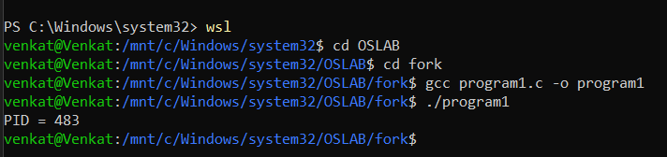

- Program 2
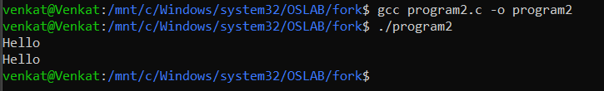
- Program 3
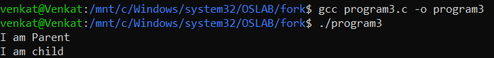
- Program 4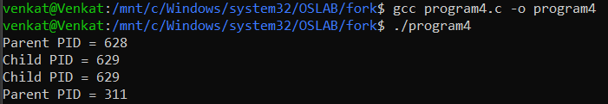
- Program 5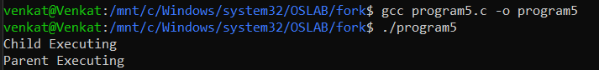
- Program 6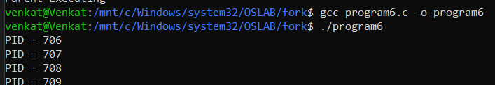
- Program 7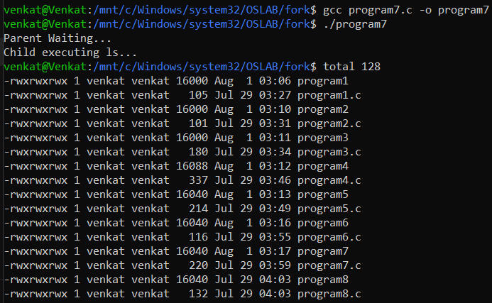
- Program 8
